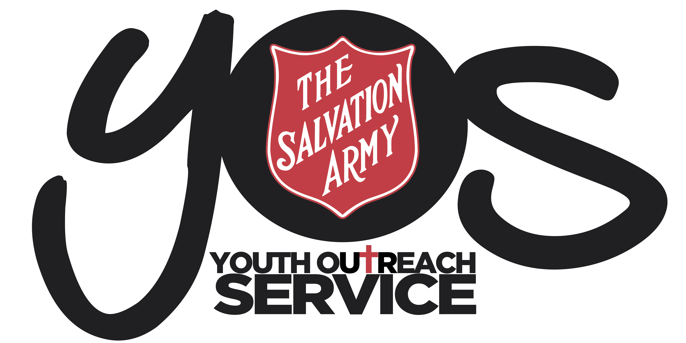

YOS Independent Schools
YOS Lawnton and Goodna Campuses
(A Queensland Non-State Independent School)
SUBJECT: 21: SEXUAL HARASSMENT POLICY |  | CODE:  SHP2018
Scope of Application: | Students, parents and employees, including full-time, part-time, permanent, fixed-term and casual employees, as well as contractors, volunteers and people undertaking work experience or vocational placements
Filing Instructions: | F Drive  - Management Security – Editable version  - School folders - PDF version
Related policies legislation: | - Anti-Discrimination Act 1991 (Qld)  - Sex Discrimination Act 1984 (Cth)  - The Salvation Army EEO, Discrimination, Harassment and Bullying Policy  - The Salvation Army Australia Eastern Territory Organisational Code of Conduct  - YOS Independent Schools Anti-Discrimination Policy  - YOS Independent Schools Disability Discrimination Policy  - YOS Independent Schools Child Protection Policy  - YOS Independent Schools Dispute Resolution Policy and Procedures
Forms | YOS Independent Schools Dispute Resolution Form

Change record / revision history:

Version | Prepared/ reviewed by | Date reviewed | Approved by | Authorised by | Review date
21.1 | Helen Boardman | December 2018 | Darren McGhee | Thomas Austin | December 2020

Purpose
The purpose of this policy is to protect students and employees from sexual harassment.

Policy Statement
All students and employees at YOS Independent schools have the right to learn and work in an environment free from sexual harassment. YOS Independent schools will provide a fair and safe learning and teaching environment where all students and employees have equal opportunities.

Employees, volunteers and anyone involved in the operations of a Salvation Army Youth Outreach Service are required to adhere to The Salvation Army “EEO, Discrimination, Harassment and Bullying Policy”, which can be accessed on the TSA Intranet.
YOS Independent schools is committed to taking action to protect students and employees from sexual harassment and to responding appropriately should such behaviour occur, including possible discipline.

Any instances of sexual harassment should be reported under YOS Independent schools Dispute Resolution Policy and Procedure for students and The Salvation Army Salvation Army EEO, Discrimination, Harassment and Bullying Policy for staff.

In particular, and in accordance with the legislation, it is YOS Independent School’s policy that:
- An employee at the school must not sexually harass anyone in the course of their duties, including another employee, a student at the school or someone seeking to become a student at the school, or a student at another school
- An adult student at the school must not sexually harass another student or employee at the school or a student or employee at another school

Definitions

- Sexual harassment - a person sexually harasses another person if:
- the person makes an unwelcome sexual advance, or an unwelcome request for sexual favours, to the person harassed; or
- engages in other unwelcome conduct of a sexual nature in relation to the person harassed;
- in circumstances in which a reasonable person, having regard to all the circumstances, would have anticipated the possibility that the person harassed would be offended, humiliated or intimidated.
Sexual harassment can take various forms and may be obvious or indirect, physical or verbal. Specific examples of sexual harassment include:
- Unwelcome physical touching
- Sexual or suggestive comments, remarks insinuation, jokes or innuendo
- Unwelcome requests for sex
- Intrusive questions about a person's private life
- Showing a person sexually explicit images or material e.g. On a phone or computer
- Indecent exposure
- Unwanted invitations of a sexual nature
- Leering
- Sex based insults or taunts
- Sexually offensive communications, including telephone calls, letters, faxes, email and computer screen savers
Some forms of sexual harassment, such as assault, physical molestation, stalking, sexual assault and indecent exposure, are also criminal offences and should be reported to the police.
- Adult student - an adult student means a student who has attained the age of 16 years

Responsibilities

School Responsibilities
YOS Independent schools acknowledges its responsibility to provide an environment free from sexual harassment and will undertake the following steps to prevent and appropriately respond to any instances of sexual harassment;

- Maintain and implement this sexual harassment policy to assist in preventing any instances of sexual harassment
- Educate and train relevant employees to assist in preventing any instances of sexual harassment and to appropriately respond to any instances of sexual harassment
- Establish appropriate grievance and complaints procedures via its YOS Independent School’s Dispute Resolution Policy and Procedures to appropriately respond to any instances of sexual harassment
- Remove any discriminatory or offensive materials, rules and practices to assist in preventing any instances of sexual harassment
- Encourage employees and students to contribute to a healthy workplace culture to assist in preventing any instances of sexual harassment

Student and Employees Responsibilities

- All students and employees at YOS Independent schools have a responsibility not to engage in sexual harassment against any person and to support another person if they are being harassed
Equity Contact Officer role
- Provide consistent informed advice to students, parents and colleagues
- Raise staff awareness on harassment issues
- Educate staff and students on the Policy and Procedures
- Facilitate early resolution of incidents of discrimination or harassment
- Provide a safe environment for staff to express concerns in a confidential manner
- Make recommendations to management about ways to prevent further incidents
- Assist in promoting a workplace free from discrimination and harassment

Implementation

YOS Independent schools aims to provide a safe and non-judgemental learning environment for students, where they are safe from any form of harassment and discrimination. Some ways in which YOS Independent schools hope to achieve this is through:

Creating awareness around discrimination

Highlighting this policy in team meetings

Visual aids throughout the school; giving the students space and time to develop posters to put up
  - Having discussions with students around what is harassment and the effects it can have on people
  - Through curriculum
- Training for employees on how to prevent and manage sexual harassment
- Establishing a Dispute Resolution Policy and Procedure that students can understand and come to a positive and constructive solution
- Keeping appropriate records, monitor and reports on discrimination procedures
- Designate an Equity Contact Officer
- Encourage a healthy school culture by:
  - Not having offensive materials displayed
  - Encouraging students and parents to create and maintain a healthy learning environment and school culture by:
    - Having a positive and respectful attitude
    - Having appropriate programs/ workshops that promote team work and student cohesiveness
    - Understanding of what is appropriate (Curriculum)

Compliance and Monitoring

YOS Independent schools will ensure any discrimination is addressed in accordance to our Restorative Justice Framework and Dispute Resolution Policy and Procedures and it is brought to the Principal’s attention for further actions are to be taken and if police involvement is required.

Any forms that are completed will be kept on the student or staff member’s file and made easily accessible, including being attached to SAMIS file for students.

YOS Independent schools endeavour to show transparency with the community through:
- Posting policies on the website
- Reporting strategies used to decrease the incidences and increase awareness of sexual harassment, in the Annual General Meeting Report.
