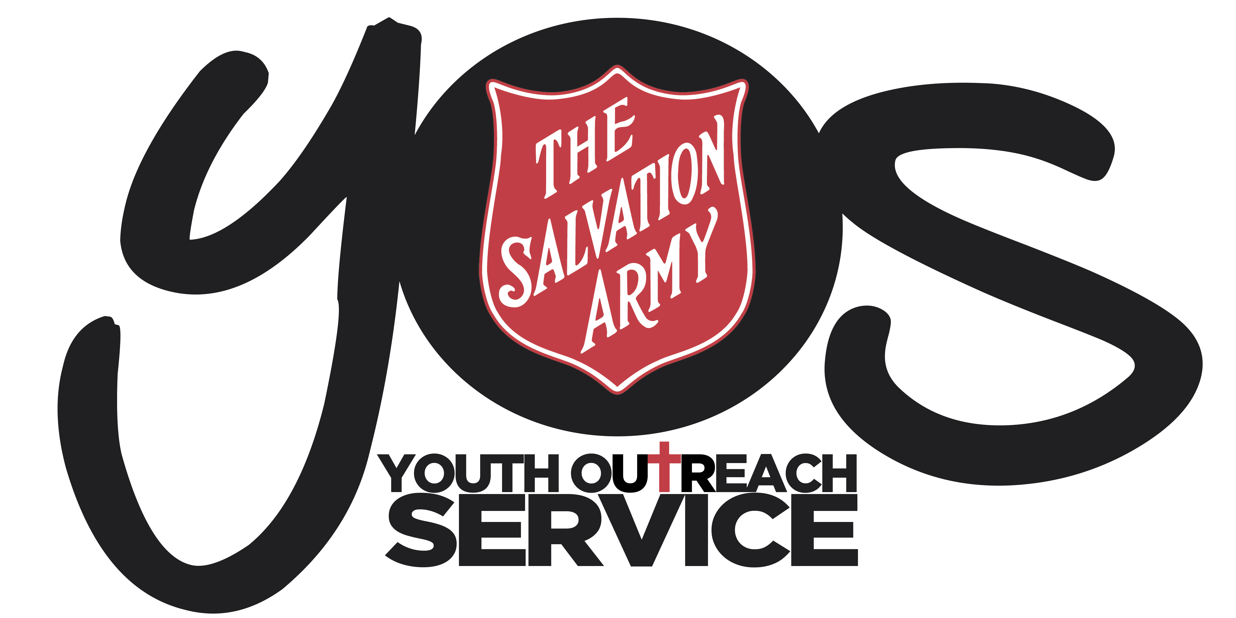
ACCEPTABLE USE OF ICT SERVICES
POLICY

YOS Independent Schools
Lawnton and Goodna Campuses
(A Queensland Non-State Independent School)

SUBJECT:  ALCOHOL, TOBACCO AND ILLICIT DRUGS  POLICY AND PROCEDURE |  | CODE:  ATID2018
Scope of Application: | All students, including those aged 18 years and over, parent / carers, staff and volunteers
Filing Instructions: | F:drive  - Management Security – Editable version  - School folders - PDF version
Related policies / legislation: | - Tobacco and Other Smoking Products Act 1998 (Qld)  - Liquor Act 1992 (Qld)  - Australian Privacy Principles  - Salvation Army Eastern Territory – Drugs and Alcohol Policy  - YOS Privacy Policy  - YOS Independent Schools: Enrolment Policy and Procedure  - YOS Independent Schools Positive Behaviour Policy  - YOS Independent Schools Restorative Justice Framework
Form Links | YOS Independent School Enrolment Contract

Change record / revision history:

Version | Prepared/ reviewed by | Date reviewed | Current Version | Approved by | Authorised by | Review date
4.1 | Helen Boardman | 18/12/2018 | YES | Darren McGhee | Thomas Austin | December 2020

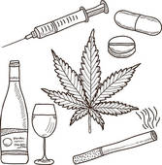
Purpose
The purpose of this policy is to prevent the possession, use, sale and distribution of alcohol, tobacco and illicit drugs and related implements by students, Parent / carers, staff and volunteers, whilst attending school or at a school-related activity.

Policy Statement
Alcohol, tobacco and illicit drugs are substances that can cause serious physical, psychological and emotional harm to an individual.

YOS Independent Schools in line with The Salvation Army Drug and Alcohol Policy, located on the intranet is an alcohol and illicit drugs free area and does not permit the use, possession, sale and/or distribution of these prohibited substances on or surrounding the premises or when representing The Salvation Army.

For further information regarding Salvation Army Drug and Alcohol policy relating to staff please refer to above policy mentioned. YOS Independent Schools will however continue to support students who are affected by these substances, while also maintaining a safe working environment for both staff and other clients.

As stated in The Salvation Army Non–Smoking Policy and in accordance with Work Health and Safety Legislative obligations, YOS Independent Schools maintains a smoke–free work environment for all officers, employees, volunteers, clients, students, contractors and other visitors to the site. This also includes the use of electronic cigarettes.

Smoking is prohibited within any and all buildings and vehicles which are owned, leased or otherwise occupied by The Salvation Army, or within any other workplace in which Salvation Army business is conducted. Smoking is not permitted while wearing any form of Salvation Army corporate uniforms, including work clothing which displays a TSA logo. The designated smoking area is required to be 10 meters from any entrance, window or ventilation system.

Under Queensland Health Tobacco legislation, smoking is not permitted within 5m of the perimeter of the school, including structures in this area such as bus shelters and car parks.
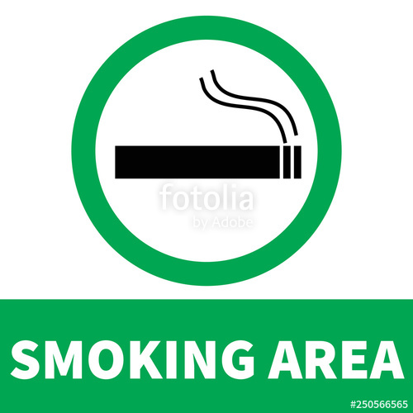
Designated Smoking Area

Lawnton Campus
There is a designated smoking area for students located behind the church building, which adheres to all policies and legislation, based on the school premises being the two leased buildings and not the surrounding grounds.

Lawnton Campus will continue to work with students towards encouraging healthy lifestyle choices and ensure students are aware of the affects smoking and substance abuse may have.

Goodna Campus
There is a designated smoking area for students located at the back of Soundpoint at the end of the footpath which adheres to all policies and legislation, based on the school premises being the two leased buildings and not the surrounding grounds.

Goodna Campus will continue to work with students towards encouraging healthy lifestyle choices and ensure students are aware of the affects smoking and substance abuse may have.

Definitions
- Illicit drugs: are taken to include illegal drugs and related implements, as well as legal drugs and substances being used for non-medical (i.e. recreational) purposes.

Examples would include cannabis, dexamphetamine used for non-medical purposes and inhalants such as spray paints.

Responsibilities

School Responsibilities
YOS Independent Schools acknowledges its responsibility to:
- Develop and implement this Policy to help ensure the safety of students
- Communicate this Policy to students, parent / carers and employees
- Keep appropriate records on SAMIS and through Incident reporting, monitor and report on any issues related to the use, possession, sale or distribution of alcohol, tobacco and illicit drug or related implements at the school or at school-related activities
- Encourage students, parent / carers and employees to contribute to a healthy school culture
- Offer / provide education and interventions regarding substance abuse including the use of tobacco
- Offer/ provide students with one on one support when dealing with substance abuse when required
- Provide referrals to external services if required

Employee Responsibilities

At YOS Independent Schools, employees have a responsibility to:
- Uphold the school’s policy and The Salvation Army Drugs, Alcohol and non-smoking policy on this issue
- Try to prevent and appropriately respond to any instances of use, possession, sale or distribution of alcohol, tobacco or illicit drugs or related implements at the school or at school-related events, in accordance with this Policy.
- Provide non-judgemental support and an environment where students can feel comfortable to discuss this area of their lives and the impacts it may be having

Parent / Carer Responsibilities
At YOS Independent Schools, parent / carers have a responsibility to:
- Ensure, as far as possible, that their child does not use, possess, sell or distribute alcohol, tobacco or illicit drugs or related implements at the school or at school-related events

Student Responsibilities
At YOS Independent Schools, students have a responsibility to:
- Not use, possess, sell or distribute alcohol, or illicit drugs or related instruments whilst at school or attending school-related activities
- Discuss with Health and Wellbeing Worker if support is needed

Implementation
YOS Independent Schools will communicate to all school staff and volunteers the acceptable process to follow if students are found to be in possession of alcohol, tobacco, illicit substances and unsanctioned prescription medication, through orientation and revision every two years after policy review.

Students will be made aware of this policy at enrolment and through curriculum and discussions with students throughout the semester; to encourage healthy lifestyle choices and the negative impact tobacco, alcohol and Illicit drugs can have on your physical, emotional and physiological wellbeing. This may be conducted by YOS staff or external service providers.

YOS Independent Schools will encourage staff and students to create a healthy school culture and offer peer support and encouragement to work towards their goals through class activities.

Compliance and Monitoring
YOS Independent Schools will ensure the appropriate records are maintained and kept on the student file and in our student database, including, but not limited to enrolment paperwork, incident reports, behavioural management plans, support plans and referral information.

YOS Independent Schools will maintain transparency and may include any alcohol, tobacco and illicit drug data relevant in the AGM report each year, to ensure the community is aware of the issues our students face. This policy will also be listed on the website for the community, students and parent / carers to access.

Managing Substance Use Procedures
Lawnton and Goodna Campuses

If Lawnton or Goodna Campus staff become aware, or reasonably suspects, that a student has alcohol or illicit drugs at the school or at a school-related activity, the school will take the following action, as appropriate in the circumstances:

- Ensure the medical and emotional safety of the student/s concerned

- Student may choose to
- hand it over to a staff member for disposal
- not access school for the day

- Have a discussion with the student/s even if they decide not to access school for the day – see what is happening for the student on that particular day. Ensure they are safe to leave the school site

- Contact the students’ parent / carers if appropriate

- Report the matter to the police if appropriate after discussion with Principal

- Offer appropriate support to any student involved in the matter

- Follow Restorative Justice Framework and Positive Behaviour Management Policy and Procedure

- Consider the need to communicate the incident to employees, students and parent / carers, taking into account the privacy of the student/s and family concerned, the Australian Privacy Principles and the duty of care the school owes to other student

- Any substances handed to staff will not be returned to the student. Students cannot participate in any school activities that puts them and/or others at risk when they have been using a prohibited substance, especially a volatile substance.

- When ‘confronting’ young people who are substance affected ensure you communicate with colleagues and management if safety is a concern.

- If a student chooses to hand over the substance, then staff can take that substance down to the police station. No identifying details are required to be given. If it is alcohol, this can be tipped down the drain.

Refusal of Access

Lawnton and Goodna Campuses reserves the right to refuse access to our services if there is an assessed safety risk to other students and/or staff. This may include unduly intoxicated persons or persons heavily under the influence of drugs that pose a threat to staff or other clients.

Staff in breach
If staff are to be found in breach of this policy and The Salvation Army Drug and Alcohol Policy, the Principal should be notified and further action taken in consultation with The Salvation Army Performance Management Policy.

Reporting to Police
Lawnton and Goodna Campuses will only report relevant matters to the Police when it is in the student’s or school community’s best interests. Instances may include;
- a student is trafficking drugs in the school
- a student is incorrigibly taking drugs in the school
- Students and staff are at risk due to aggressive behaviour
Lawnton and Goodna Campuses will endeavor to work with the student from a Restorative Justice Framework first and will only involve the police if deemed completely necessary and/or there is an assessed risk of safety.

Searching and Confiscating Property
In accordance with YOS Independent Schools Enrolment Contract the school will search a student’s property, including lockers and bags, and may confiscate banned items, when it believes it is appropriate in the circumstances. This is noted in the students’ enrolment contract. The student is required to be present for search. It is up to the discretion of the staff member if they look through the bag themselves, but first preference would be to ask the student to empty contents themselves. Whenever possible have a second staff member present and not in the presence of other students. Ensure student is aware of what the purpose of the search is.

When items have been confiscated, Lawnton Campus/Goodna Campus will take the following action:
- If the police have been involved in the matter, give it to them, or
- If illegal, take substance down to Police Station – No details need to be given
- If alcohol, tip down the sink

