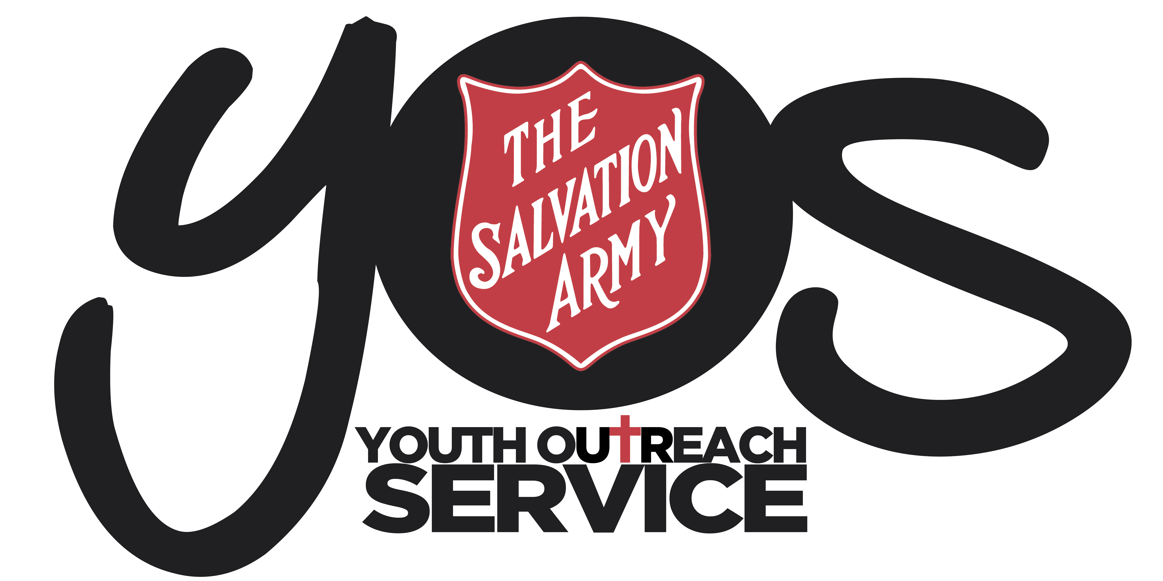

YOS Independent Schools
YOS Lawnton and Riverview College
(A Queensland Non-State Independent School)

SUBJECT:  15- FAMILY LAW PLAN |  | CODE:  FLP2018
Scope of Application: | The policy covers parents/carers, students and staff and describes how the school responds to requests by parents/carers who have no contractual arrangements with the school for information about, and access to, their child (ren).
Filing Instructions: | F Drive  - Management Security – Editable version  - School folders - PDF version
Forms
Related policies / legislation: | - YOS Independent Schools Child Protection Policy  - YOS Independent Schools Enrolment Policy  - YOS Independent Schools Privacy Policy  - Family Law Act 1975 (Cth)  - Australian Education Act 2013 (Cth)  - Australian Education Regulation 2013(Cth)

Change record / revision history:

Version | Prepared/ reviewed by | Date reviewed | Approved by | Authorised by | Review date
15.1 | Helen Boardman | December 2018 | Darren McGhee | Thomas Austin | December 2020

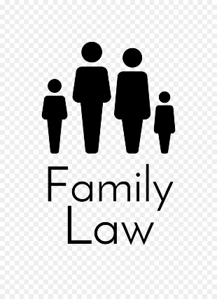
Purpose
The purpose of this policy is to outline YOS Independent School’s response to matters in relation to family law issues.

Rationale
- Schools have contractual obligations to the person who enrols the child
- Schools have a duty to take reasonable care for the safety of the child.
- Schools have no way of knowing as a fact who the natural parents of a child are
- Schools should not need to determine the current state of orders in a Family Court matter
- The Family Court seldom makes an order which a school is directed to obey

Policy
Except in exceptional circumstance outlined below, the school does not become involved in Family Court matters. It is the policy of YOS Independent School’s to provide information about a child and access to the child:
- those people whom the school believes are the natural parents of the child
- others as per the school’s contractual obligation to the enrolling party
Under the Australian Education Act 2013 and s59 of the Australian Education Regulation 2013, the school is required to provide reports to the “persons responsible for students”. YOS Independent School’s will provide school reports to the “persons responsible” as per the above definition twice a year.
In all other matters, the school will, unless aware of information to the contrary, follow the directed course of the enrolling party, as per the school’s contractual obligations to the enrolling party. If there is a disagreement between the enrolling party and others who believe they have the right of access to information about or access to the child, it is the responsibility of those parties to reach agreement independently from the school, either through consultation or court action. The school will not become involved as the arbiter in disputes of this kind.

Exceptional Circumstances
The policy is subject to 3 qualifications:
- Where a court orders otherwise and the order binds the school
- Where it is reasonably foreseeable that the safety of the child could be jeopardised
- Where the child objects and the school believes it is in the best interests of the child to heed the objection.

Definitions

Parental Responsibility
In relation to a child, means all the duties, powers, responsibilities and authority which, by law, parents have in relation to children. Each of the parents of a child who is not eighteen (18) has parental responsibility for the child. This is not affected, for example, by the parents becoming separated or by either or both of them marrying or re-marrying. [Family Law Act 1975 (Cth) s61(B); s61(C)(1)and(2)]

Parent(s):
Usually a child’s parents are the father whose sperm fertilises the mother’s ovum and the mother who conceived and gave birth to the child. These are called the “natural parents”. Other circumstances of parenthood include:
- Adoptive parents
- Step-parents may have a duty to maintain a child but only under a court order [Family Law Act 1975 (Cth) s66M]
- Where there has been artificial insemination by a donor
- Where an ovum provided by one woman is fertilised in vitro and inserted in another woman
- Where a woman acts as a surrogate and agrees to bear a child for another woman

Persons responsible for students:
The natural parents of a student are legally responsible for the student until the student turns 18 unless a parenting order has been made by the Court removing responsibility from one or both of the natural parents.

Refer to YOS Independent School’s Privacy Policy for further information regarding communication with parents/carers.

