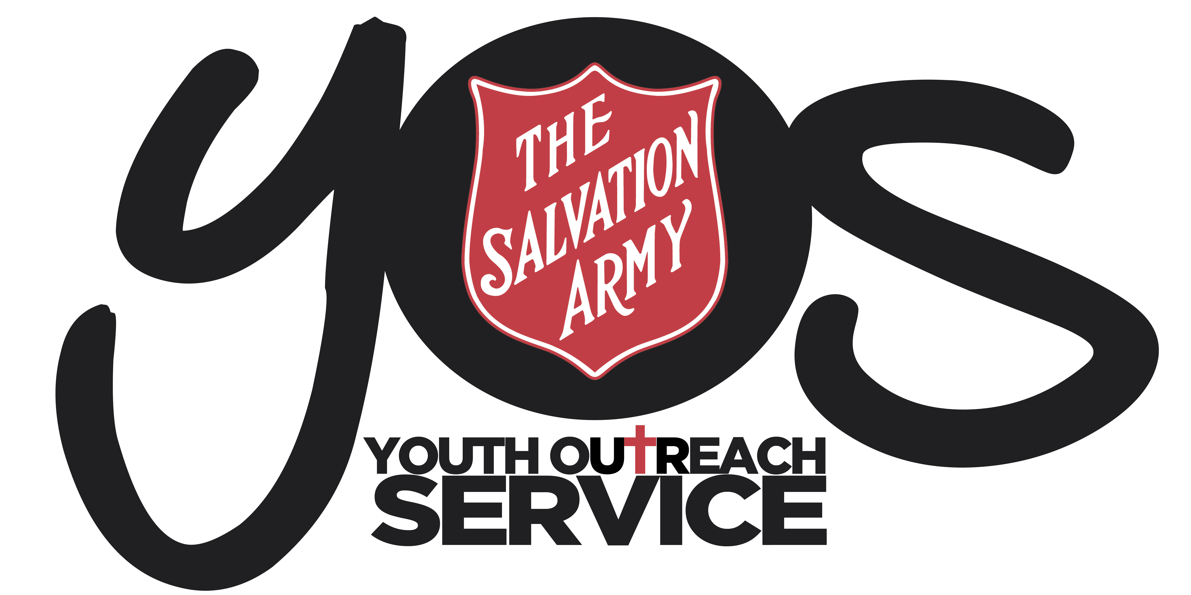

YOS Independent Schools
YOS Lawnton and Goodna Campuses
(A Queensland Non-State Independent School)

SUBJECT:  CHILD PROTECTION RISK MANAGEMENT STRATEGY |  | CODE:  CPRM2018
Scope of Application: | Students and employees, including full-time, part-time, permanent, fixed-term and casual employees, as well as contractors, volunteers and people undertaking work experience or vocational placements
Filing Instructions: | F:drive  - Management Security – Editable version  - School folders - PDF version
Forms | - The Salvation Army Safe Salvos Allegation/Suspicion of Abuse Report Form
Related policies / legislation: | - Working with Children (Risk Management and Screening) Act 2000 (Qld)  - Working with Children (Risk Management and Screening) Regulation 2011 (Qld)  - Child Protection Act 1999 (Qld)  - Education (Accreditation of Non-State Schools) Act 2017 (Qld)  - Education (Accreditation of Non-State Schools) Regulation 2017 (Qld)  - Education (General Provisions) Act 2006 (Qld)  - Education (General Provisions) Regulation 2006 (Qld)  - Education (Queensland College of Teachers) Act 2005 (Qld)  - Education and Care Services National Law (Queensland) Act 2011 (Qld)  - The Salvation Army Eastern Territory Child Protection Policy  - The Salvation Army Organisational Code of Conduct  - YOS Independent Schools Restorative Justice Framework  - YOS Independent Schools Child Protection Policy  - YOS Independent Schools Dispute Resolution Policy and Procedures  - YOS Independent Schools Risk Management Framework

Change record / revision history:
Version | Prepared/ reviewed by | Date reviewed | Approved by | Authorised by | Review date
10.1 | Helen Boardman | December 2018 | Darren McGhee | Tom Austin | December 2019

Purpose
The purpose of this strategy is to eliminate and minimise risk to a child’s safety and to ensure the safety and wellbeing of all students.

Policy Statement and a Statement about Commitment
YOS Independent schools are committed to the safety and wellbeing of students enrolled at the school. For a student to maximise a high quality of life, they will require a supportive community, a positive learning environment, social, spiritual and emotional development and the maturity of moral and social justice values.

In accordance with sections 171 and 172 of the Working with Children (Risk Management and Screening) Act 2000 (Qld), YOS Independent schools is dedicated to eliminating and minimising risks to child safety through this Strategy which includes and refers to various other policies and procedures to effectively ensure the safety and wellbeing of children in the school’s care.

This Child Risk Management Strategy is evidence of YOS Independent school’s commitment to the safety and wellbeing of children and the protection of children from harm in fulfilment of the requirements of section 3(1)(a) of the Working with Children (Risk Management and Screening) Regulation 2011 (Qld).

Implementation
In practice, YOS Independent school’s commitment to acting in accordance to the Working with Children (Risk Management and Screening) Act (“the Act”) to ensure the safety and wellbeing of students, means that it will implement the measures outlined below in points 1 - 8.
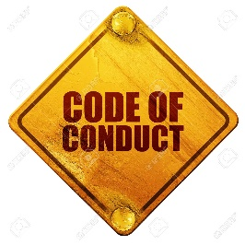

Code of Conduct
At YOS Independent schools we expect our employees to conduct themselves as stated in The Salvation Army Staff and Volunteer Code of Conduct and as follows:

- School employees are expected to always behave in ways that promote the safety, welfare and well-being of children and young people
- Personal and professional conduct must strive to create a harmonious safe and productive work environment which models our Christian Values, Ethos and Mission.
- They must actively seek to prevent harm to children and young people, and to support those who have been harmed
Specific responsibilities include:
- Employees should avoid situations where they are alone in an enclosed space with a student
- When physical contact with a student is a necessary part of the teaching/learning experience, employees must exercise caution to ensure that the contact is appropriate and acceptable. Employees must always advise the student of what they intend doing and seek their consent
- Employees must not develop a relationship with any student that is, or that can be interpreted as having a personal rather than a professional interest in a student
- Employees must not have a romantic or sexual relationship with a student
This commitment is evidence of YOS Independent schools fulfillment of the requirements of section 3(1)(b) of the Regulation.

Recruitment, Selection, Training and Management Procedures
YOS Independent schools is committed to recruiting, selecting, training and managing employees in such a way that limits risks to children.

YOS Independent schools Ensures that its recruitment and selection procedures act to reduce the risk of harm to children from employees via:
- Having accurate position descriptions
- Ensuring the successful applicant
  - is a registered teacher with the Queensland College of Teachers (who has been subject to relevant police and other safety checks) if applicable to the position
  - ensuring a current blue card is held
  - understands the responsibilities and supervision associated with the position,
  - understands the nature and environment of the service provided to children,
  - has the experience and qualifications required

- Advertising the position with a clear statement about the school’s commitment to safe and supportive work practices and identifying that candidates will be subject to a teacher registration check and Blue Card screening, a police check, referee checks, identification verification and the requirement to disclose any information relevant to the candidates’ eligibility to engage in activities including young people

- A selection process that includes assessing the application via an interview process and referee and other checks (as identified above) based on the accurate position description

- A six-month probationary period of employment, which allows the school to further assess the suitability of the new employee and to act as a check on the selection process

- Ensures that its training and management procedures act to reduce the risk of harm to children from employees via:
- Management processes that are consistent, fair and supportive
- Annual performance review processes to help employees improve their performance in a positive manner
- Supportive processes for staff when they are experiencing challenges, such as mentoring, mediation, conflict resolution, coaching, additional training and external support, supervision and counselling services
- An orientation process which thoroughly addresses the school’s policies and procedures, particularly its expectations regarding child risk management and to assist employees to understand their role in providing a safe and supportive environment for children, while reinforcing the philosophy and values of YOS Independent schools
- Training new and existing staff on an ongoing basis to enhance skills and knowledge and to reduce exposure to risks, as follows:
  - The school’s policies and procedures
  - Identifying, assessing and minimising risks to children
  - Handling a disclosure or suspicion of harm to a child
- Keeping a record of the training provided to employees
- Exit interviews to assist the school to identify broader issues of concern that may impact on the safety and wellbeing of children at the school
This commitment is evidence of YOS Independent school’s fulfillment of the requirements of section 3(1)(c) of the Regulation.

Handling Disclosures or Suspicions of Harm
Any of the types of concerns or reports below should be reported and managed under the YOS Independent schools Child Protection Policy and Procedures:
- All staff with concerns about sexual abuse or likely sexual abuse;
- Teachers with concerns of sexual or physical abuse; and
- All staff who have received a report of inappropriate behaviour by another staff member.
- Any concerns regarding harm to a student
This commitment is evidence of YOS Independent school’s fulfillment of the requirements of section 3(1)(d) of the Regulation.

Managing Breaches of this Child Risk Management Strategy
YOS Independent schools is committed to appropriately managing breaches of this Child Risk Management Strategy in accordance with its other relevant policies as appropriate in the circumstances, such as its Child Protection Policy, Employee Code of Conduct and The Salvation Army Performance Management Processes and this is evidence of fulfillment of the requirements of section 3(1)(e) of the Regulation.

Implementing and Reviewing the Child Risk Management Strategy
This Strategy in its entirety and its related policies and procedures are evidence of fulfillment of the requirements of section 3(1)(f)(i) of the Regulations relating to implementation.

The introduction to this Child Risk Management Strategy and the “Compliance and Monitoring” section below state YOS Independent school’s commitment to reviewing the Strategy annually and are evidence of fulfillment of the requirements of section 3(1)(f)(i) of the Regulation relating to review.
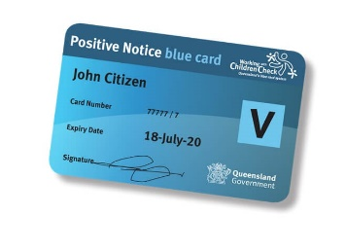

Blue Card Policies and Procedures
YOS Independent schools is committed to acting in accordance with chapter 8 of the Act relating to the screening of employees in such a way that limits risks to children. In particular, YOS Independent schools will:
- Require relevant perspective or current employees, volunteers, trainee students and school board members to apply for a Blue Card or Exemption Notice, and check the validity and appropriateness of any currently held notices as appropriate, in accordance with the school’s position descriptions and the Act
- Complete an Authorisation to confirm a valid card application when necessary
- Submit a Change in police notification form when notified by employee that such a change has occurred
- Review of YOS employees’/volunteers blue cards every month through discussion at Senior Team
- Request reporting on blue card status and renewal through HR Data Management
- Not allow a person to continue to work with children if their Blue Card or Exemption Notice is cancelled or suspended or a negative notice is received after a change of police information
- Submit a No longer with organisation form when appropriate
- Appoint a school contact person who will be responsible for managing the screening process and all related documentation and records
- Keep written records of all the above actions, decisions and outcomes, including the dates of expiry of Blue Cards and Exemption Notices
- Ensure that all information in relation to Blue Cards and Exemption Notices is kept confidential
- Act to remind employees to keep their Blue Card or Exemption Notice up to date
This commitment is evidence of YOS Independent school’s fulfillment of the requirements of section 3(1)(f)(ii) of the Regulation.

High Risk Management Plans
YOS Independent School’s Risk Management Framework is evidence of fulfillment of the requirements of section 3(1)(g) of the Regulation.

YOS Independent schools is committed to identifying risks, assessing risks, eliminating and minimising risks and the monitoring of risk to the safety of children on an ongoing basis. YOS Independent schools will utilise various risk management tools to assist it in this process and will keep appropriate records of decisions made and actions taken in relation to risks to children.

Strategies of Communication and Support
YOS Independent school’s commitment to making this Child Risk Management Strategy available to students, parents and employees via its enrolment package, staff induction and website, is evidence of fulfillment of the requirements of section 3(1)(h)(i) of the Regulation.

YOS Independent schools is committed to training employees in relation to risks to children and will conduct this training regularly via annual formal training events, informal updates at staff meetings and regular discussions between managers and their staff, and this is evidence of fulfillment of the requirements of section 3(1)(h)(ii) of the Regulation.

Responsibilities
YOS Independent school is responsible for developing and implementing this Child Risk Management Strategy and related policies and procedures to ensure it fulfills its obligations.

All employees are responsible for acting in compliance with this Child Risk Management Strategy and related policies and procedures.

Compliance and Monitoring
YOS Independent schools is committed to the annual review of this Strategy and will record, monitor and report to the Principal, The Salvation Army Board and the Senior Executive Team regarding any breaches of the Strategy.

In addition, the school is committed to other various compliance and monitoring arrangements made under relevant policies and procedures.

The Salvation Army Code of Conduct

