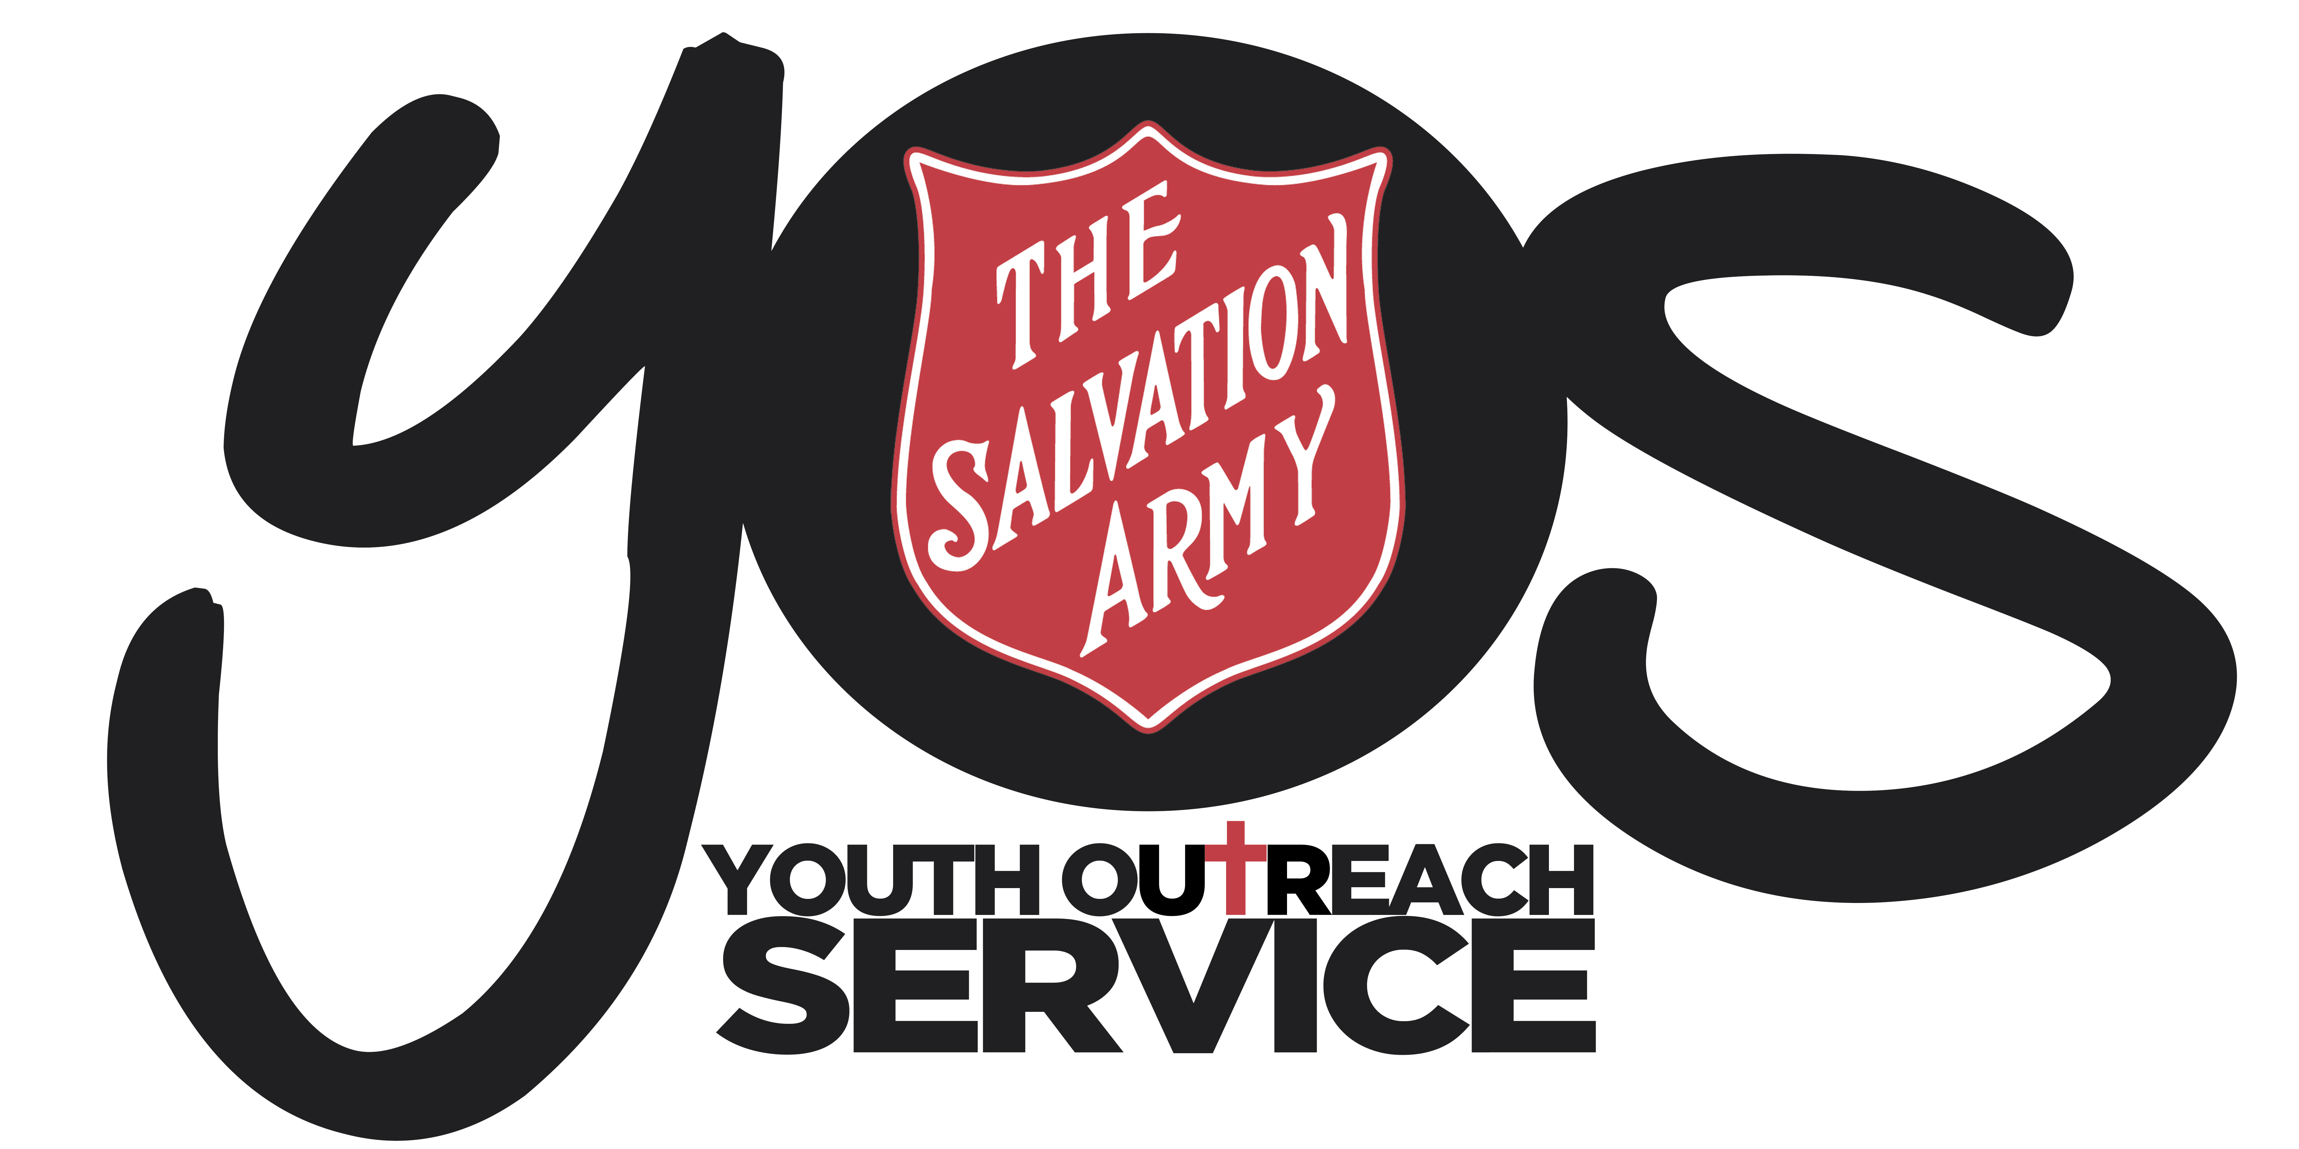
ACCEPTABLE USE OF ICT SERVICES
POLICY

YOS Independent Schools
Lawnton and Goodna Campuses
(A Queensland Non-State Independent School)

SUBJECT:  DISPUTE RESOLUTION POLICY |  | CODE:  DRP2018
Scope of Application: | Students, parents and employees, including full-time, part-time, permanent, fixed-term and casual employees, as well as contractors, volunteers and people undertaking work experience or vocational placements
Filing Instructions: | F drive  - Management Security – Editable version  - School folders - PDF version
Related policies legislation: | - Education (Accreditation of Non-State Schools) Regulations 2017  - Australian Education Regulations 2013  - Fair Work Act 2009  - Work Health and Safety Act 2011 (Qld)  - Privacy Act 1988 (Cth)  - Anti-Discrimination Act 1991 (Qld)  - Australian Human Rights Commission Act 1986 (Cth)  - Sex Discrimination Act 1984 (Cth)  - Age Discrimination Act 2004 (Cth)  - Disability Discrimination Act 1992 (Cth)  - Racial Discrimination Act 1975 (Cth)  - The Salvation Army Code of Conduct for employees  - YOS Independent School Child Protection Policy and Procedure  - YOS Independent School Work Health and Safety Policy  - YOS Independent School Anti-Discrimination Policy  - YOS Independent School Sexual Harassment Policy  - YOS Independent School Disability Policy  - YOS Independent School Student Bullying Policy  - YOS Independent School Privacy Policy  - YOS Independent School Restorative Justice Framework
Form Links | YOS Independent Schools Dispute Resolution Form

Change record / revision history:

Version | Prepared/ reviewed by | Date reviewed | Approved by | Authorised by | Review date
13.1 | Helen Boardman | 18/12/2018 | Darren McGhee | Thomas Austin | December 2020

Purpose
The purpose of this policy is to ensure that student, parent and employee disputes are dealt with in a responsive, efficient, effective and fair way.

Policy Statement
YOS Independent Schools view complaints and disputes as part of an important feedback and accountability process. YOS Independent Schools acknowledges the right of students, parents and employees to complain when dissatisfied with an action, inaction or decision of the school and the school encourages such feedback. YOS Independent Schools recognise that time spent on handling disputes can be an investment in better service to students, parents and employees.

YOS Independent Schools facilitate a student and parent’s ability to raise complaints and to appeal decisions. All complaints and appeals are to be addressed promptly, confidentially and with fairness. Students and parents are entitled to make an appeal against any decision.

The client’s ability to raise complaints is important in ensuring that:
- The student’s needs are being met
- Service provision is adequate and transparent
- Communication is facilitated between the client and the service

Please note, due to staff being employed by The Salvation Army, when there is an employee/volunteer workplace dispute, employees are to be directed to procedures located in The Salvation Army Grievance Handling Policy and Procedure.

Types of Disputes that may be Resolved under this Policy
YOS Independent Schools encourage students and parents to promptly lodge concerns regarding harassment, discrimination, bullying, privacy breaches and non-compliance with child protection processes as well as more general complaints that include areas such as;

The School, employees or students have done something wrong | One off spur of the moment comment
The School, employees or students have failed to do something they should have done | Issues of student or employee behaviour that are contrary to the relevant code of conduct
The school, employee or students having acted unfairly or impolitely | Workplace Health and Safety issues
Issues related to learning programs, assessment and reporting of student learning | Issues related to communication between, students, parents or between employees
General administrative issues

Students and parents can discuss complaints with a staff member as an informal conversation and if they feel they would like to make a formal complaint the Dispute Resolution Form is required to be completed.

Student complaints may be brought by students or by parents/carers on behalf of their children, as appropriate in the circumstances.

Issues Outside of this Policy
The following matters are outside of the scope of this policy and should be managed as follows:
- Child protection concerns or risks of harm to children should be dealt with in accordance with the law and the school’s Child Protection Policy
- Student bullying complaints should be dealt with under the Student Bullying Policy and Procedures and Restorative Justice Framework
- Student discipline matters, including matters involving Time Out or Exiting, should be dealt with under the Positive Behaviour Policy and Procedures and the Restorative Justice Framework
- Employee complaints related to their employment should be directed to their supervisor and handled through The Salvation Army Grievance Handling Policy and Procedure
- Student or employee violence or criminal matters should be directed to the Principal who will involve the Police as appropriate
- Formal legal proceedings

Dispute Resolution Principles
YOS Independent Schools are committed to managing disputes according to the following principles:
- Disputes will be resolved with as little formality and disruption as possible
- Disputes will be taken seriously
- Disputes will be handled in a trauma informed and restorative way
- Anonymous complaints will be treated on their merits like any other dispute when possible
- Disputes will be dealt with fairly and objectively and in a timely manner
- Mediation, negotiation and informal resolution are optional alternatives to investigation
- Procedural fairness will be ensured wherever practicable
- Natural justice principles will be observed wherever practicable
- Confidentiality and privacy will be maintained as much as possible
- All parties to the dispute will be appropriately supported
- All parties are entitled to reasonable progress updates
- Appropriate remedies will be offered and implemented
- A review mechanism will be offered
- Complainants, respondents and people associated with them will not be victimised as a result of lodging the dispute nor will they suffer any other reprisals
- The school will keep confidential records of disputes
- Students with a disability, impairment, literacy issues can access the same support and assistance as a student without and processes as required will put in place to assist this
- The school’s insurer will be informed if a complaint could be connected to an insured risk

Responsibilities

School
The school has the following role and responsibilities:
- Develop, implement, promote and act in accordance with the school’s Dispute Resolution Policy and Procedures
- Appropriately communicate the school’s Dispute Resolution Policy and Procedures to students, parents and employees
- ensure that the Dispute Resolution Policy and Procedures are readily accessible by students, parents and employees
- Upon receipt of a dispute, manage the dispute in accordance with the Positive Behaviour Management Policy and Restorative Justice Framework
- Provide factual information to the parties involved within 5 working days regarding the process and maintain ongoing communication between all involved
- Ensure that appropriate support is provided to all parties to a dispute
- Take appropriate action to prevent the victimisation or action in reprisal against the complainant, respondent or any person associated with them
- Appropriately implement remedies
- Appropriately train relevant employees
- Keep appropriate records
- Monitor and report on disputes
- refer to the school’s governing body immediately any claim for legal redress

All Parties to a Dispute
The complainant and respondent have the following role and responsibilities:
- Apply and comply with the school’s Dispute Resolution Policy and Procedures
- Lodge disputes promptly as soon as possible after the issue occurs or as otherwise appropriate
- Expect that the dispute will be dealt with fairly and objectively; in a timely manner; with procedural fairness wherever practicable; that natural justice principles will be observed wherever practicable; that confidentiality and privacy will be maintained as much as possible
- Provide complete and factual information in a timely manner
- Not provide deliberately false or misleading information
- Not make frivolous or vexatious complaints
- Act in good faith, and in a calm and courteous manner
- Show respect and understanding of each other’s point of view, values and cultural differences
- Act in a non-threatening manner
- To be appropriately supported
- Acknowledge that a common goal is to achieve an outcome acceptable to all parties
- Recognise that all parties have rights and responsibilities which must be balanced
- Maintain and respect the privacy and confidentiality of all parties
- Not victimise or act in reprisal against any party to the dispute or any person associated with them

Employees Receiving Disputes
Employees receiving disputes have the following role and responsibilities:
- Act in accordance with the school’s Dispute Resolution Policy
- Inform the party lodging the dispute of how disputes can be lodged, when they should be lodged and what information is required
- Provide the complainant with information about any support, advocacy or assistance available to assist the complainant in lodging their complaint taking into consideration any disability, impairment, literacy level.
- Provide the complainant with a copy of the school’s Dispute Resolution Policy and Procedures
- Maintain confidentiality
- Keep appropriate records
- To forward complaints to more senior employees, including the Principal, as appropriate
- To be appropriately supported
- Not victimise or act in reprisal against the complainant, respondent or any person associated with them

Implementation
YOS Independent Schools are committed to:
- Raising awareness of the process for resolving disputes at the school, including the development and implementation of this policy and related procedures, and via the clear support and promotion of the policy and procedures through
  - Orientation of new staff
  - Brochures outlining procedure at reception for the community to access
  - Training at the beginning of the school year and at review of policy
  - Discussion at Enrolment with new students
  - Accessibility through the website
- Appropriately training relevant employees (especially senior staff) on how to resolve disputes in line with this policy, using trauma informed and restorative practices
- Keeping appropriate records of disputes, will monitor disputes and their resolution and will report on significant reports to the school Board on dispute resolution at the school
- Documentation to be saved on:
  - On f drive
  - In students file and SAMIS
- Encouraging students, parents and employees to contribute to a healthy school culture where disputes are resolved with as little formality and disruption as possible by using the Restorative Justice Framework, Natural Justice Principles and Trauma Informed Care.

Compliance and Monitoring
YOS Independent Schools will ensure any disputes are addressed in accordance to this policy and using our Restorative Justice Framework

The Annual General Report will be distributed to members of the community and also listed on the YOS website alongside this policy, which will outline statistics and further relevant information relating to this policy to show transparency with the community.

DISPUTE RESOLUTION PROCEDURE

- For the procedure regarding dispute resolution please see the Dispute Resolution Flow Chart.

- Please note if the Head of School Operations and Student Support Services is involved in the dispute, the matter should be taken to the Principal or the Governing Board.

- If a student or parent would like to make a formal complaint and requires assistance filling out the document, a staff member that is not involved in the dispute can assist.

- Form to be completed is the Dispute Resolution Form

- Managing disputes are to be trauma informed and in conjunction with the Restorative Justice Framework
Communicating the Client’s Rights to Appeal
The communication of the client’s right to make an appeal is to be given verbally or in writing.

Once a request for an appeal has been given:
- Discussion is to be had with parties involved to determine what is required to be done and Resolution Procedures to commences from the beginning
- Ensure that after an appeal has been lodged, clients are made comfortable in accessing school, and are not victimised
- Advise clients about their right to request an advocate and support as required
- Attempt to resolve appeals quickly
- Where appeals are not resolved at school level, refer them to the Governing School Board. Regular reviews of progress towards the resolution of appeals needs to take place within a time frame mutually agreed with the client
In the case of any allegation that is of a criminal nature, refer the complaint immediately to the Principal for a decision regarding passing complaint on to the appropriate external body for investigation such as Police, with notification to Salvation Army Divisional Headquarters.

Depending on the nature of the dispute, clients may choose to contact outside bodies such as;
- The Police
- The State or Territory statutory child protection authority
- The Anti-Discrimination Board or Human Rights Commission
- Office of the Ombudsman
- The local member of Parliament

YOS Independent Schools
DISPUTE RESOLUTION FLOW CHART
A student or parent can lodge a complaint/appeal
INFORMAL OR FORMAL?
(Assistance can be given to make a written formal complaint if required)

FORMAL

INFORMAL

Complainant completes the Dispute Resolution/Appeal Form and submits it to the Head of School Operations and Student Support Services. If deputy is involved in the dispute, submit to the Principal.

To ensure a permanent accurate record for future action and reference, complaints presented not using the standard complaints form will be attached to the form.

YOS will endeavor for disputes to be handled where the problem has occurred by using Restorative Justice and Natural Justice Principles

IS IT RESOLVED?
Complainant makes a verbal complaint to a YOS staff member

NO

YES

YES
Dispute has been resolved
The complainant should be notified of the process to follow within 5 working days, following the Restorative Justice Framework and natural justice principals as a guide for interventions.

Discussions are to be had with all parties to assist in arranging an intervention and ensure all parties are safe
IS IT RESOLVED?

All documentation is to be kept on F: drive and in SAMIS

The complainant can discuss the issue further with the Head of School Operations and Student Support Services and then the Principal if not resolved further

To make an appeal to what had been decided complete an Appeal form or discuss with a staff member

IS IT RESOLVED?

NO
YES

