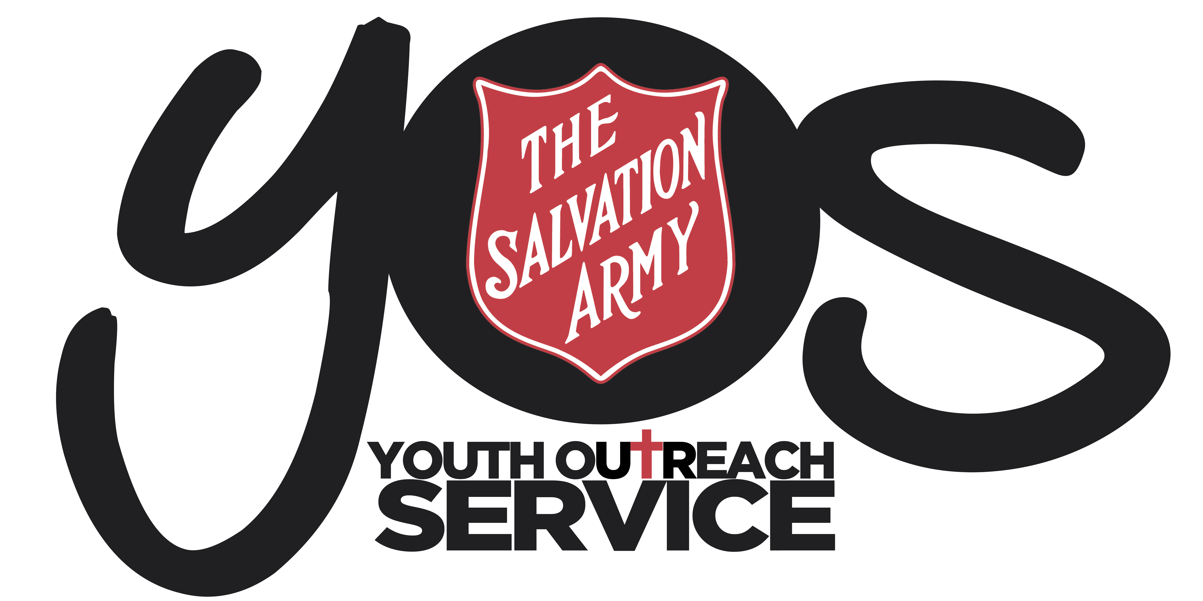
ACCEPTABLE USE OF ICT SERVICES
POLICY

YOS Independent Schools
YOS Lawnton and Goodna Campuses
(A Queensland Non-State Independent School)

SUBJECT:  COPYRIGHT POLICY |  | CODE:  COPY2018
Scope of Application: | Students and employees, including full-time, part-time, permanent, fixed-term and casual employees, as well as contractors, volunteers and people undertaking work experience or vocational placements
Filing Instructions: | F:drive  - Management Security – Editable version  - School folders - PDF version
Related policies / legislation: | - Copyright Act 1968 (Cth)  - Copyright Regulations 1969 (Cth)  - The Salvation Army Copyright Statement  - The Salvation Army Information Technology Security Policy  - The Salvation Army Internet and Email Use Policy  - YOS Independent Schools Acceptable Use of ICT Services Policy

Change record / revision history:

Version | Prepared/ reviewed by | Date reviewed | Approved by | Authorised by | Review date
11.1 | Helen Boardman | December 2018 | Darren McGhee | Thomas Austin | December 2020

Purpose
The purpose of this policy, in conjunction with The Salvation Army Copyright Statement is to recognise and protect the rights of copyright owners and uphold our obligations and protecting our right under the Copyright Act 1968 (Cth).

Policy Statement

The Salvation Army Copyright Statement is available through link above. Areas that are covered in the TSA Policy, which are not covered directly in this document are:
- How long does copyright protection last?
- Rights afforded to copyright owners/creators of works
- Right to control reproduction within TSA
- Moral Rights
- Performer’s Rights which covers:
  - Literary, dramatic, artistic and musical works
  - Films, sound recordings, broadcasts and published editions

In addition, YOS Independent Schools is committed to:
- Recognising and protecting the rights of copyright owners by complying with the restrictions on reproducing or communicating copyright materials as laid down in the Copyright Act 1968 (Cth)
- Informing students and employees of their rights and responsibilities under legislation and the various licencing arrangements of the school so that they may make full legal use of the materials available to them
- The fair regulation and management of copyright materials created at the school by employees, volunteers, researchers and students

Employee and Volunteer Copyright

Please see The Salvation Army Copyright Statement which covers, employees, volunteers and contractor/ freelancers.

Student Copyright
In relation to copyright created by YOS Independent School students:
- Copyright of work created by students in the course of their studies will belong to the student, unless an agreement to the contrary is established between the student and the school
- Whilst a student’s work may be used within YOS Independent Schools for educational purposes, permission will be gained from the student and/or parent for any further use of the work

Definitions

a) What is Copyright?
Essentially, copyright is a set of rights given to the authors or creators of “works”. Works include all literary, dramatic, artistic and musical works (see definitions with examples in part 3.1 below). Copyright protects the expression of an idea or concept, but does not protect the actual idea or concept itself. That is, the idea or concept must be actually used and embodied in a “work”. For example, an idea for a movie is given expression in the form of a script. The idea can then be protected as a literary work (the script).

(b) Copyright in Australia
Copyright law protection is automatic from the moment you place your work in material form, and does not require registration (for example, formally writing down, recording or filming your work). A work does not need to be published to be protected by copyright. This means that any work you do that meets the criteria to receive copyright protection will be protected by copyright without any additional action needing to be undertaken by you. Some people may not even be aware that they have created copyrighted material but notwithstanding this, they will still have rights that the law will protect.

(c) Copyright overseas
Works published in Australia generally receive copyright protection in overseas countries as well, however, in some countries it is necessary to register a work to ensure it receives full copyright protection. Works published in countries that are signatories to the major international copyright conventions and treaties generally receive the same copyright protection as those published in Australia. If you are faced with international copyright issues, contact the THQ Legal Department for specific advice.

Moral rights -
Individual creators have rights called “moral rights”, whether or not they own copyright. These are the rights to:
- be attributed as the creator of their work
- take action if their work is falsely attributed as being someone else’s work or is altered by someone else but attributed as if it were unaltered; and
- take action if their work is distorted or treated in a way that is prejudicial to their honour or reputation.
Responsibilities

School Responsibilities
YOS Independent Schools acknowledges its responsibility to undertake appropriate licensing arrangements to prevent copyright infringements by the school’s students and employees, including attributing moral rights whenever relevant.

Furthermore, YOS Independent Schools also recognises its obligation to undertake the following steps to prevent copyright infringements:
- Develop and implement a Copyright Policy
- Educate and train employees
- Keep appropriate records, monitoring and reporting on copyright license issues
- Encourage students and employees to contribute to a copyright-compliant school culture

Student and Employee Responsibilities

All students and employees at YOS Independent Schools must uphold the school’s policy on copyright as follows:
- All students and employees have a responsibility not to infringe upon copyright either under the Copyright Act 1968 or under the terms of any licence the school holds
- Students and employees should note that the school does not in any way condone the use of school equipment or systems for any type of copyright infringement. In particular, computers or internet accounts should not be used to download infringing copies of music, videos, games or unlicensed software, as under the YOS Independent Schools Acceptable Use of ICT Services Policy
- All employees should ensure that they do no instruct, authorise or condone any infringement of the Copyright Act 1968 by students or other employees
- All employees have a duty not to use school copyright material for private purposes unless permission is granted first
- Students can make a copy of a “reasonable portion” of copyright material under the Fair Dealings provisions in the Copyright Act 1968, for the purposes of research or study. Students should consult the guidelines on the copyright website or speak to relevant employees to gain a better understanding of the amount and uses considered to be “fair”
- If a student or an employee believes that copyright infringing behaviour is occurring in the school, they should report it to the Principal
- All students are to sign a YOS Independent Schools Plagiarism Agreement at enrolment (as part of the ICT Contract)

Preventing Infringements
Compliance with TSA’s legal obligations when using copyrighted materials of others
Where TSA wishes to use works of a third party, it is important that TSA does not infringe the rights of the copyright holder. An infringement will arise if TSA uses copyright material without permission. The rights of copyright owners/creators or works must be considered as follows:
1. Right to Reproduction
Where TSA wishes to use another’s work, TSA will generally need to seek the permission of the copyright holder unless one of the exemptions discussed below applies. The grant of permission may involve a grant of licence or assignment of right in return for a fee or royalty.
2. Moral Rights
Moral rights are explained above. Violating the moral rights of another will amount to infringement of those rights. This will occur, for example, if a TSA employee uses someone else’s work without properly acknowledging the creator of the work in a clear and reasonably prominent manner.
3. Performers’ Rights
TSA must not carry out the following activities without first obtaining permission of the holder of the performers’ rights:
- Record a performance by a third party of that third party’s original works
- Make a copy of an unauthorised recording of a performance by a third party of that third party’s original works
- Place an unauthorised recording online of a performance by a third party of that third party’s original works.
Other ways that infringement may occur:
- Authorising infringement (e.g. if TSA endorses material containing a third party’s work that infringes a copyright holder’s rights)
- Importing certain types of items that contain copyright material
- Selling items containing copyright material which were imported into Australia without the permission of the copyright holder.

Exemptions
There are many exemptions in the Copyright Act that allow for use of works without requiring the permission of the copyright owner. The creator of the works, however, continues to hold moral rights in the works and as such, wherever the works are being reproduced, the creator of the works must be attributed in a clear and reasonably prominent manner.
Some exemptions in the Copyright Act that may be relevant to the activities of TSA are:
Research or study for the purpose of promoting and facilitating education. Dealing under this exception must not only be for research and study, but must also be fair. Things to consider regarding fairness include: the purpose and nature of use of the work, the type of the work and whether it is commercially available, the amount of work copied and the market effect of the usage. There is a common misconception that a ‘10% change / copying rule’ applies, however, this is not the case. Rather, reasonableness should be gauged with common sense and principles of fairness kept in mind.
Reporting news for the promotion of the free flow of knowledge, ideas and information.
Giving professional advice for the purposes of facilitating the administration of justice, with the interest of assisting people to understanding their legal obligations and rights.
Copying by library or archives for the purpose of facilitating research or study. This exception allows, with consent from the library, use of material that is a reasonable portion of the publication and not to be used for any other purpose than for research and study.
Educational institutions and institutions assisting persons with an intellectual or print disability -reproduction and communication of works and other subject-matter to make multiple copies of works for teaching.
Performance of literary, dramatic or musical works or other subject-matter in the course of educational instruction.
Use of works and broadcasts for educational purposes.
In accordance with the Copyright Act 1968, YOS Independent Schools will take the following actions to prevent infringements of copyright:
- Use free for education material and free for education uses content whenever possible
- Arrange a direct licence for relevant material whenever appropriate through TSA
- Seek access to appropriate licence arrangements for relevant material through Independent Schools Queensland
- Undertake all other reproduction and communication of copyright material in accordance with the Fair Dealing provisions of the Copyright Act 1968
- Attribute moral rights whenever appropriate
- At enrolment and when submitting an assessment, students signing that it is their own work

Implementation

The use of other people’s intellectual property is an important part of research and informing a student’s learning. YOS Independent Schools understands that this needs to be done in compliance with the Copyright Act1968 (Cth) and prevent copyright infringements. YOS Independent Schools will endeavour to do this through:
- Awareness – Ensuring staff and students understand the rules around copyright and this Policy is easily accessible to students and employees via:
  - Website
  - F Drive
  - Discussion at enrolment and in class
- Training is offered to staff if deemed appropriate
- Up to date records will be kept which will include direct licences sought by the school, ISQ and TSA, which are made easily accessible and located in a file.
- Through curriculum:
  - Creating a school culture where pride is taken in developing one’s own work and encouragement is given to develop critical thinking, creativity and imagination. While recognising the importance of input from external sources to support students work and referencing them appropriately
The following five options are available when copying or communicating material at school:
1. Free for education material;
2. Free for education uses;
3. Direct licences;
4. Direct licences for ISQ-member schools;
5. Fair dealing.

- Free for education material
There are a range of websites which provide copyright free material for use by educational institutions:
- Scootle (previously known as The Le@rning Federation);
- Creative Commons material;
- NEALS material;
- Other free material (independently sourced by the school).

- Free for education uses
There are a number of general provisions in the Copyright Act 1968 which outline situations where it is practical for schools to use certain copyright material without relying on a licence scheme or seeking permission from the copyright owner, including:
- Exam Provisions (section 200 of the Copyright Act 1968);
- Copying by Hand (section 200 of the Copyright Act 1968);
- Performance and Communication in class (section 28 of the Copyright Act 1968);
- Flexible Dealing (section 200AB of the Copyright Act 1968).

- Direct licences
A direct licence means contacting the copyright owner to obtain permission to use copyright material. The value in obtaining a direct licence is that you can often acquire a much broader permission than if you were to rely on the central licences for ISQ-member schools. Another benefit is that the usual copyright royalties are not charged on licensed materials

- Direct licences for ISQ-member schools
ISQ negotiates and pays for a number of licences with collecting societies which allow member schools to use specific types of copyright material for specific purposes. Schools belonging to, and paying licensing fees to ISQ on an annual basis for all of the following Copyright Licence Agreements, do not have to seek permission, or collect copying data every time employees copy or communicate copyrighted materials for educational purposes. There are five main licences which ISQ-member schools are able to belong to:

    - Licence to use text and artistic works (Copyright Agency Limited [CAL]);
    - Licence to copy and communicate television and radio broadcasts (Screenrights);
    - Licence to perform music (APRA);
    - Licence to record music (ARIA);
    - Licence to photocopy print music (AMCOS)

5. Fair Dealing
Under the fair dealing provision in the Copyright Act 1968, students and teachers are allowed to use a reasonable portion of copyright material for a number of purposes without seeking permission or making payment to the copyright owner, including for the following purposes:
- Reporting the news
- Criticism or review
- Research or study
- Parody or satire

To find out what current direct licenses YOS Independent Schools have, discuss with the Principal.

For further information about Copyright Law, access

Australia Copyright Council information for Education:
http://www.copyright.org.au/ACC_Prod/ACC/Public_Content/Information_Sheets_by_What_You_Do.aspx?WebsiteKey=8a471e74-3f78-4994-9023-316f0ecef4ef

Smartcopying: The Official Guide to Copyright Issues for Australian Schools and TAFE
http://www.smartcopying.edu.au/

Compliance and Monitoring

YOS Independent Schools those facilitated by ISQ and TSA in a named file, located onsite.

YOS Independent Schools will undertake the CAL (Copyright Agency Limited) survey if required and keep copying records for the duration of FLC’s participation in the survey. If your school is selected by CAL to undertake a survey, ISQ can assist with this process.

YOS Independent Schools staff will report any copyright infringements to the Principal who will in turn report to TSA legal department if required.

The Salvation Army Copyright Statement
The Salvation Army Copyright Statement
The Salvation Army Copyright Statement
www.copyright.org.au/admin/cms.../59740730752392bfe8f263.pdf
The Salvation Army Copyright Statement

