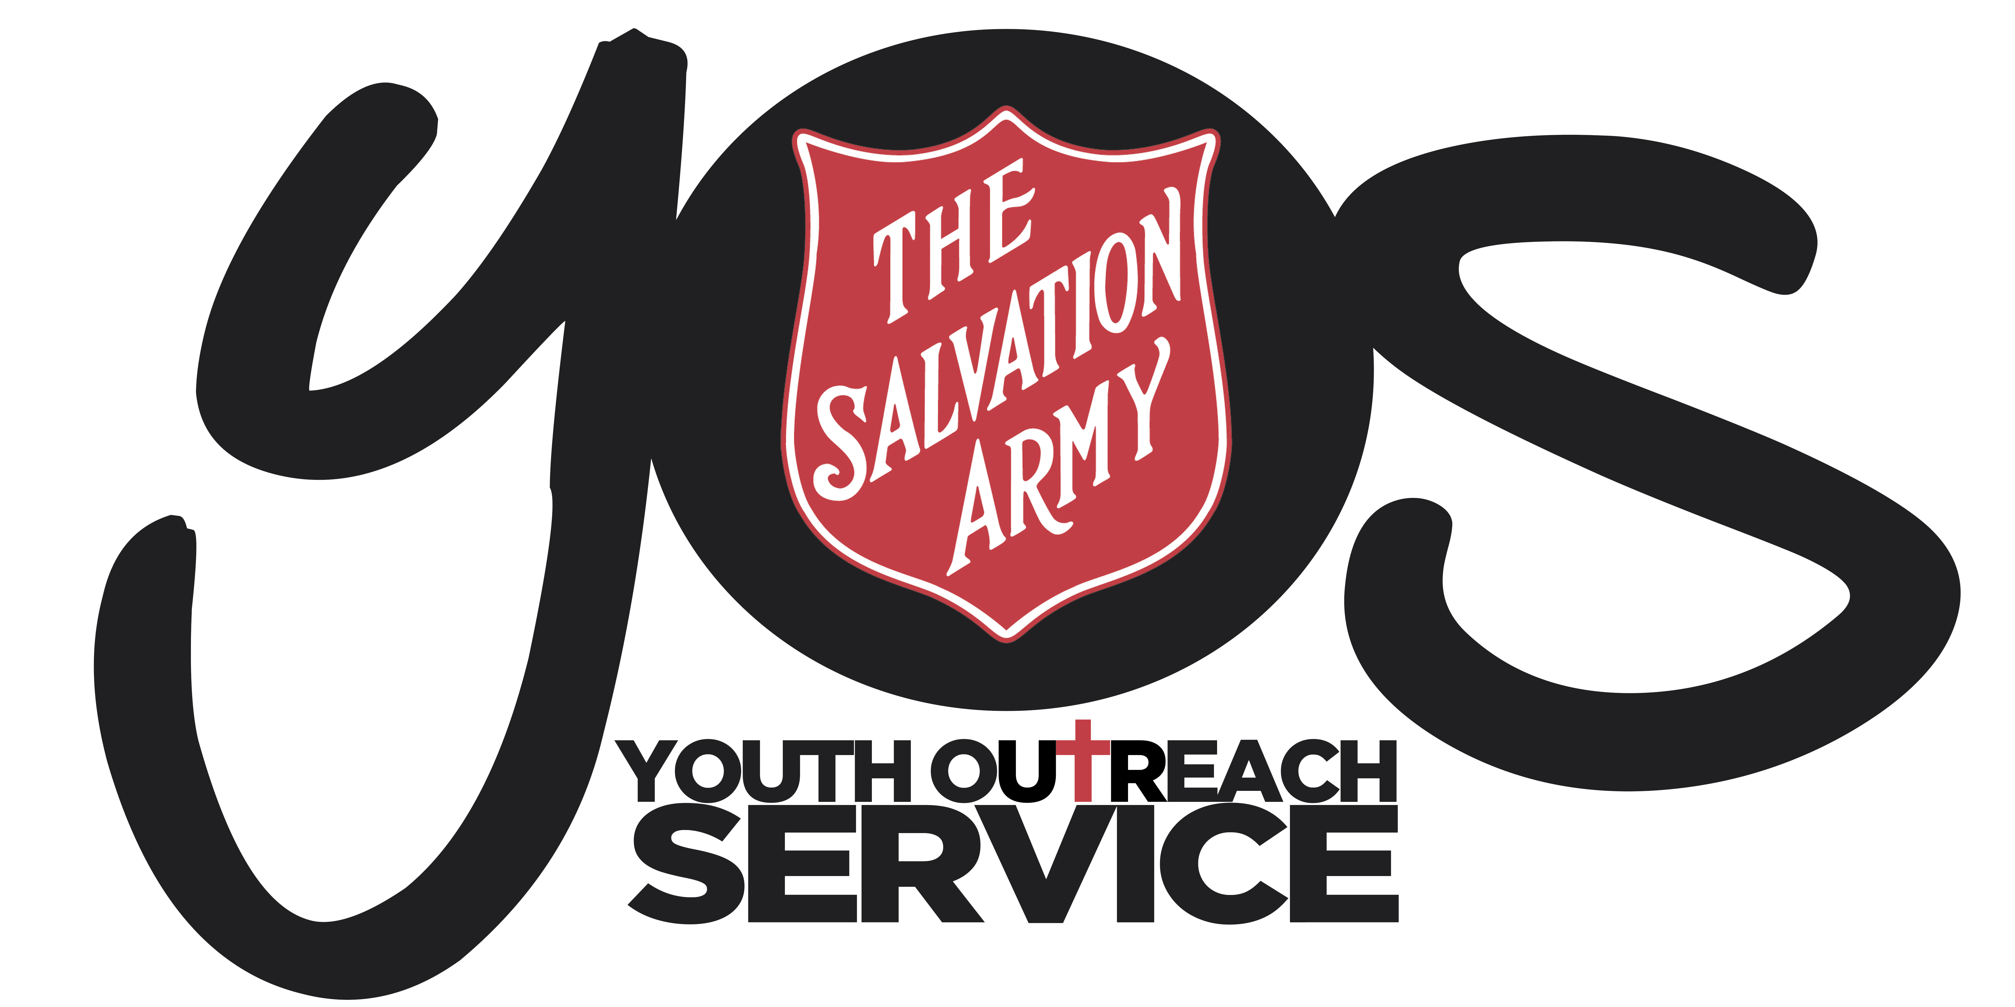

YOS Independent Schools
YOS Lawnton and Goodna Campuses
(A Queensland Non-State Independent School)

SUBJECT:  RISK MANAGEMENT FRAMEWORK |  | CODE:  RMF2018
Scope of Application: | All staff and other persons at the school, including students and parents
Filing Instructions: | F Drive  - Management Security – Editable version  - School folders - PDF version
Related policies / legislation: | - The Salvation Army Australia Eastern Territory Work, Health and Safety Policy  - All relevant Salvation Army Australia Eastern Territory WHS Policies accessible from:  The Salvation Army WHS Management System
Forms | - Risk Assessment and Control Form  - Incident & Injury Report Form  - Hazard Report Form  - Incident and/or Injury Investigation Report Form

Change record / revision history:

Version | Prepared/ reviewed by | Date reviewed | Approved by | Authorised by | Review date
20.1 | Helen Boardman | December 2018 | Darren McGhee | Thomas Austin | December 2020

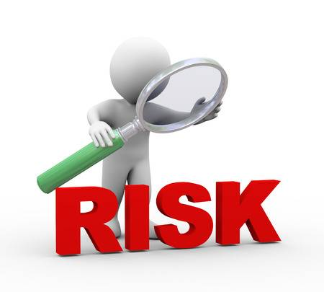
Purpose
There are potential risks everywhere, but YOS Independent Schools as a program of The Salvation Army is committed to the “assessment and subsequent elimination or control of all identified hazards”. YOS Independent Schools will do everything within reason to protect students, staff and parents from harm while they are accessing the facility and being involved in the program. Where it may not be ‘reasonably practicable’ to eliminate the risk, controls will be put in place to lessen the risk of harm to the lowest possible level.

YOS Independent Schools will ensure prompt reporting of hazards and incidents and further Investigation if required.

The below Salvation Army Policies and Procedures are to be used for the school program:

- Risk Assessment and Control Procedure
- Risk Assessment and Control Form

- Hazard Management Policy
- Hazard Management Procedure

- Incident and Injury Reporting Policy
- Incident and Injury Reporting Procedure
- Incident & Injury Report Form

- Incident and/or Injury Investigation Policy
- Hazard and Incident Investigation Procedure
- Incident and/or Injury Investigation Report Form
- Hazard Report Form

- Notifications of Incidents Queensland Procedure

All these, plus more can be located on The Salvation Army WHS Management System

Safety Assessment and Control
YOS Independent Schools staff are to ensure the safety of staff, students and other people on site as reasonably possible.

Staff are to complete The Salvation Army Risk Assessment and Control Form for any activity /extracurricular activity onsite or offsite where possible risks can be foreseen.

Permission slips are also required to be signed by the student’s parent/guardian if appropriate. These slips are required to have the:
- Date and Time of activity
- Where activity will be held
- Description of activity
Verbal consent can be taken as a last option with details of phone conversation recorded in students file and on SAMIS

Hazard Management
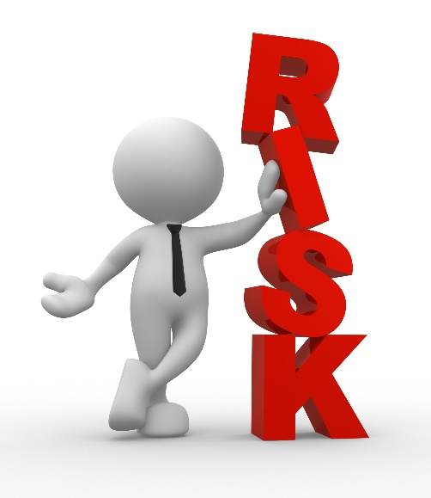
YOS Independent Schools will endeavour to identify, assess, control and evaluate any hazards that arise in consultation of the Hazard and Risk Management Policy and Procedure mentioned at the beginning of this document.

Accident, Injury or Critical Incidents
Where possible, staff must attempt to prevent accidents and injury to staff, volunteers and service users in accordance with the requirements of the Workplace Health and Safety Act.

If any client under the age of 16 years is hospitalised, staff must endeavour to inform their legal guardian as soon as practicable and if appropriate and be prepared to travel in the ambulance if required.

All accidents, injuries or critical incidents must be recorded through the relevant forms, listed as links at the beginning of this policy, as soon as possible and not later than 24 hours after the event, to the Principal.

Flow chart follows outlining steps:

Steps to follow for Accidents, Injury or Critical Incidents

The Salvation Army WHS Procedure P4-03 – Safety Assessment & Control
The Salvation Army WHS Procedure P4-01 – Hazard Management

